# My Academic Digital Champion Badge Application

User: Happy Learner

Email: [happy.learner@gmit.ie](mailto:happy.learner@gmit.ie)

## Required Courses completion:

Screen grab of progress in the Academic Digital Badge Champion course.

Also verifiable by username happylearner in cpdlearnonline.

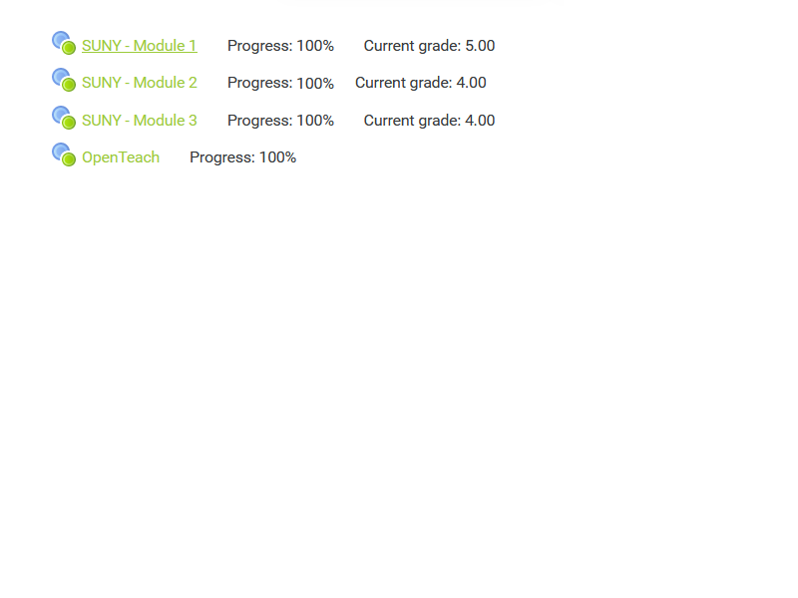

## My Completed Microsoft Courses:



Here is a screenshot from my user profile on Microsoft Education Centre

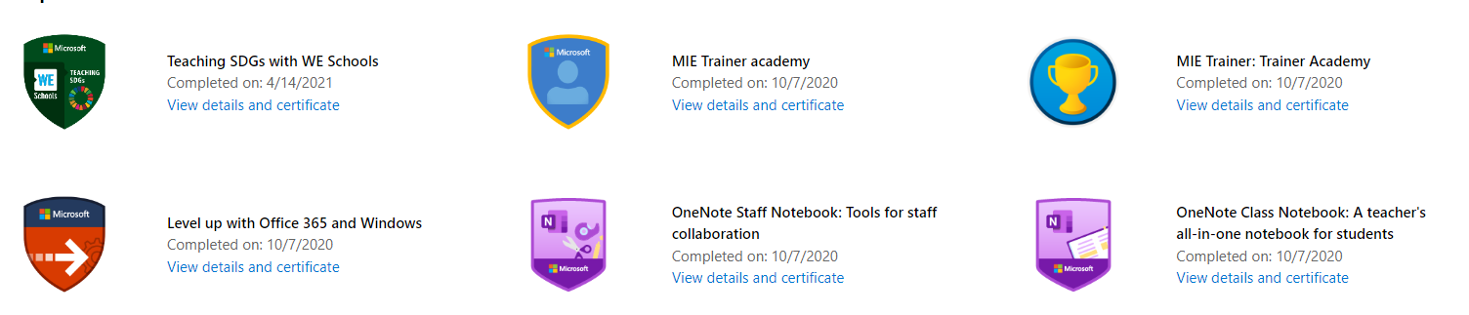

## Skills Sharing:

In January this year I delivered staff training on the use of OneNote.

After seeing it used in another course, I learned more about it on Microsoft Education Centre and experimented using it with my class. Using this knowledge, I delivered a 1hr training session that showed staff how to use the Class Notebook for collaboration, group work and assignments.

The recording of this session is here: <https://web.microsoftstream.com/video/34804838-f694-485e-9290-336c1c21eec4>